Schwab Market Data Loader - Class & Functional Breakdown

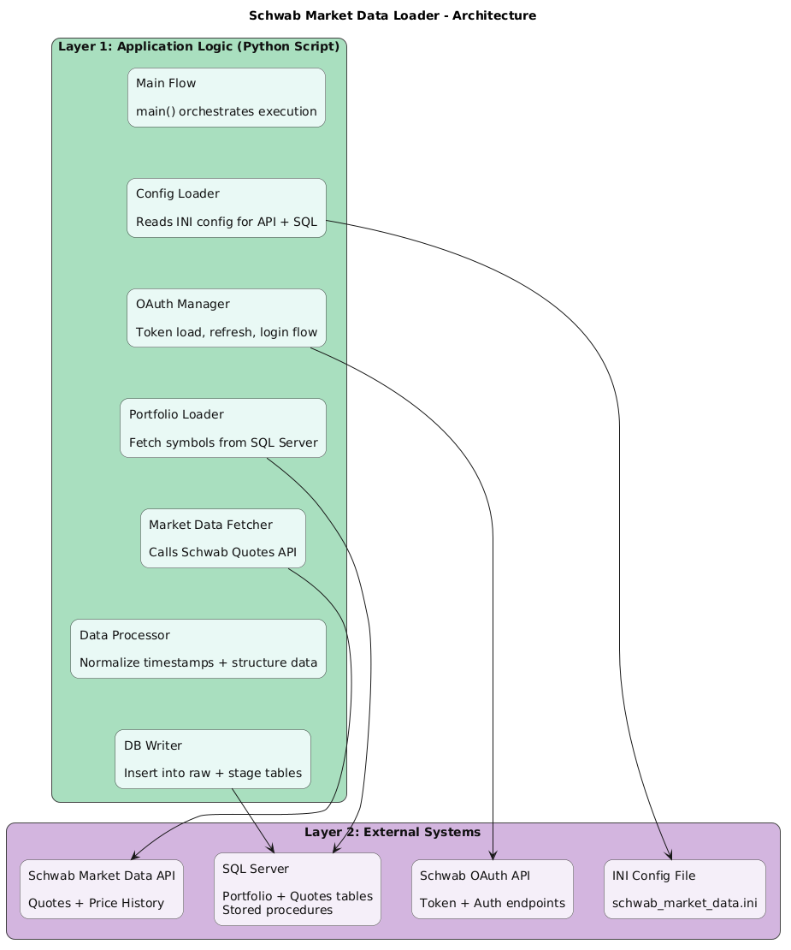

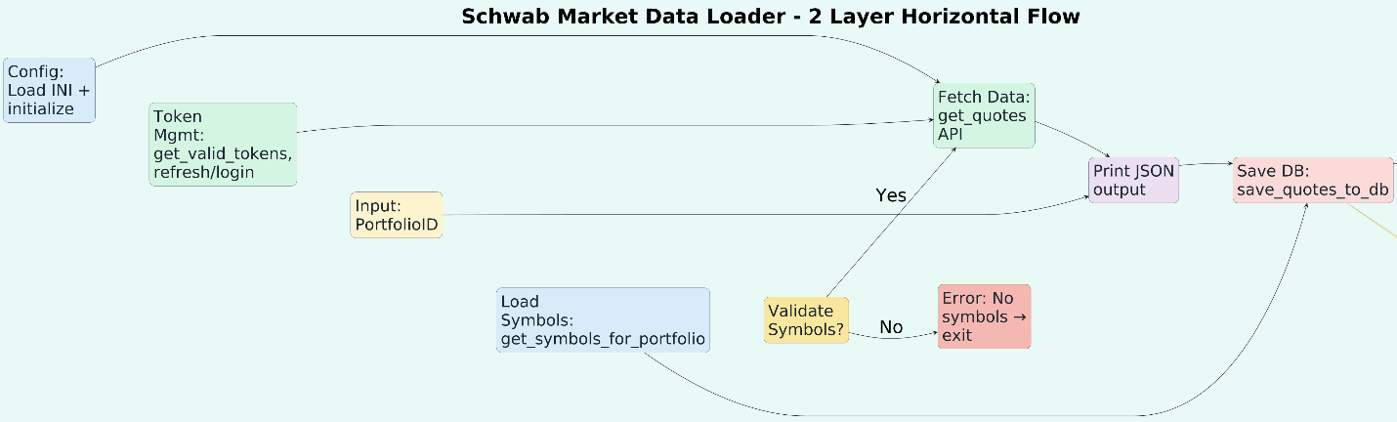
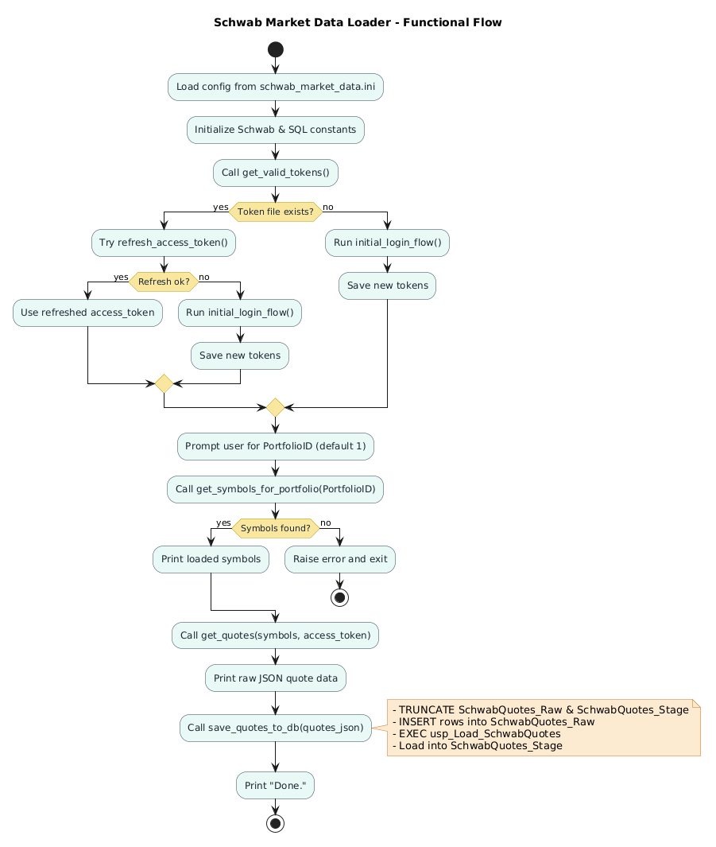
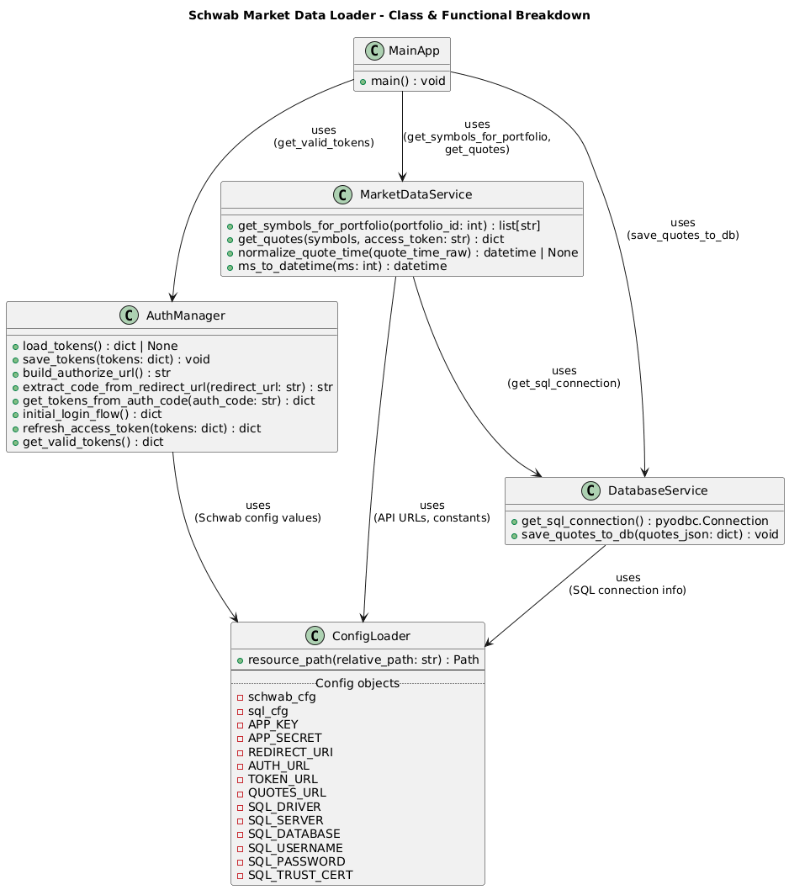


@startuml SchwabMarketData_ClassDiagram

title Schwab Market Data Loader - Class & Functional Breakdown

'== Pseudo-classes to group related functions ==

class ConfigLoader {
+resource_path(relative_path: str) : Path
--
..Config objects..
- schwab_cfg
- sql_cfg
- APP_KEY
- APP_SECRET
- REDIRECT_URI
- AUTH_URL
- TOKEN_URL
- QUOTES_URL
- SQL_DRIVER
- SQL_SERVER
- SQL_DATABASE
- SQL_USERNAME
- SQL_PASSWORD
- SQL_TRUST_CERT
}

class AuthManager {
+load_tokens() : dict | None
+save_tokens(tokens: dict) : void
+build_authorize_url() : str
+extract_code_from_redirect_url(redirect_url: str) : str
+get_tokens_from_auth_code(auth_code: str) : dict
+initial_login_flow() : dict
+refresh_access_token(tokens: dict) : dict
+get_valid_tokens() : dict
}

class MarketDataService {
+get_symbols_for_portfolio(portfolio_id: int) : list[str]
+get_quotes(symbols, access_token: str) : dict
+normalize_quote_time(quote_time_raw) : datetime | None
+ms_to_datetime(ms: int) : datetime
}

class DatabaseService {
+get_sql_connection() : pyodbc.Connection
+save_quotes_to_db(quotes_json: dict) : void
}
class MainApp {
+main() : void
}

'== Relationships between modules ==

MainApp --> AuthManager : uses\n(get_valid_tokens)
MainApp --> MarketDataService : uses\n(get_symbols_for_portfolio,\nget_quotes)
MainApp --> DatabaseService : uses\n(save_quotes_to_db)

MarketDataService --> DatabaseService : uses\n(get_sql_connection)
AuthManager --> ConfigLoader : uses\n(Schwab config values)
MarketDataService --> ConfigLoader : uses\n(API URLs, constants)
DatabaseService --> ConfigLoader : uses\n(SQL connection info)

@enduml

Functional Flow (High-Level Activity Diagram)


@startuml SchwabMarketData_Flow

title Schwab Market Data Loader - Functional Flow

skinparam backgroundColor white
skinparam shadowing false

' Activity styling
skinparam activity {
BackgroundColor #E8F8F5
BorderColor #2C3E50
FontColor #1B2631
DiamondBackgroundColor #F9E79F
DiamondBorderColor #B7950B
}

skinparam note {
BackgroundColor #FDEBD0
BorderColor #CA6F1E
}

start

:Load config from schwab_market_data.ini;
:Initialize Schwab & SQL constants;

:Call get_valid_tokens();

if (Token file exists?) then (yes)
:Try refresh_access_token();
if (Refresh ok?) then (yes)
:Use refreshed access_token;
else (no)
:Run initial_login_flow();
:Save new tokens;
endif
else (no)
:Run initial_login_flow();
:Save new tokens;
endif

:Prompt user for PortfolioID (default 1);
:Call get_symbols_for_portfolio(PortfolioID);

if (Symbols found?) then (yes)
:Print loaded symbols;
else (no)
:Raise error and exit;
stop
endif

:Call get_quotes(symbols, access_token);
:Print raw JSON quote data;

:Call save_quotes_to_db(quotes_json);

note right
- TRUNCATE SchwabQuotes_Raw & SchwabQuotes_Stage
- INSERT rows into SchwabQuotes_Raw
- EXEC usp_Load_SchwabQuotes
- Load into SchwabQuotes_Stage
end note

:Print "Done.";

stop

@enduml



@startuml SchwabMarketData_2Layer_Horizontal

scale 1.3

title Schwab Market Data Loader - 2 Layer Horizontal Flow

left to right direction

' ===== Light Green Background =====
skinparam backgroundColor #E8F8F5
skinparam shadowing false

' ===== Title Styling =====
skinparam titleFontSize 46
skinparam titleFontStyle bold

' ===== Fonts =====
skinparam defaultFontSize 40
skinparam wrapWidth 220

skinparam rectangle {
RoundCorner 25
BorderColor #2C3E50
FontColor #1B2631
FontSize 36
MinimumWidth 220
Padding 35
}

skinparam note {
FontSize 30
Padding 25
BackgroundColor #FCF3CF
BorderColor #B7950B
}

' ===== Height spacing =====
skinparam nodesep 100
skinparam ranksep 120

' ===== Layer 1 =====
rectangle "Config: Load INI + initialize" as A #D6EAF8
rectangle "Token Mgmt: get_valid_tokens, refresh/login" as B #D5F5E3
rectangle "Input: PortfolioID" as C #FCF3CF
rectangle "Load Symbols: get_symbols_for_portfolio" as D #D6EAF8
rectangle "Validate Symbols?" as E #F9E79F

A -[hidden]-> B
B -[hidden]-> C
C -[hidden]-> D
D -[hidden]-> E

' ===== Layer 2 =====
rectangle "Fetch Data: get_quotes API" as F #D5F5E3
rectangle "Print JSON output" as G #EBDEF0
rectangle "Save DB: save_quotes_to_db" as H #FADBD8
rectangle "End: Done" as I #D5F5E3
rectangle "Error: No symbols → exit" as X #F5B7B1

F -[hidden]-> G
G -[hidden]-> H
H -[hidden]-> I

' ===== Flow =====
A --> F
B --> F
C --> G
D --> H

E --> F : Yes
E --> X : No

F --> G
G --> H
H --> I

' ===== Note =====
note right of H
TRUNCATE tables
INSERT raw data
EXEC procedure
Load stage table
end note

@enduml

